Installing node

Go to <https://nodejs.org/en/download/> and download 64bit: 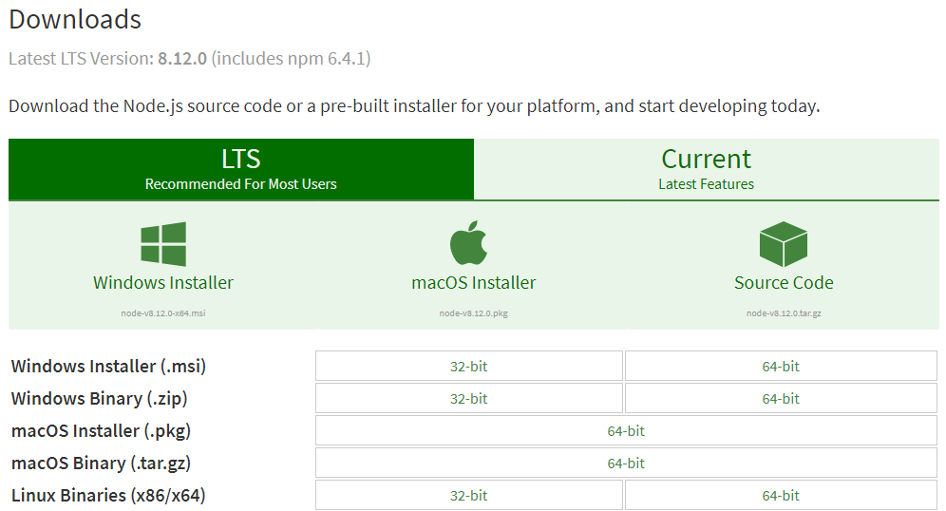

When downloaded, run the installer:

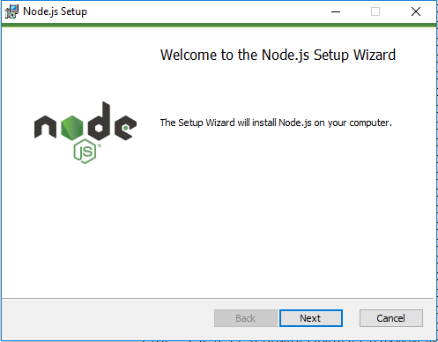

Accept the license agreements and click “next” through all the default options.

Once installed, verify via the “npm –v”command: